Here are some books if you want to know more about our feathered friends
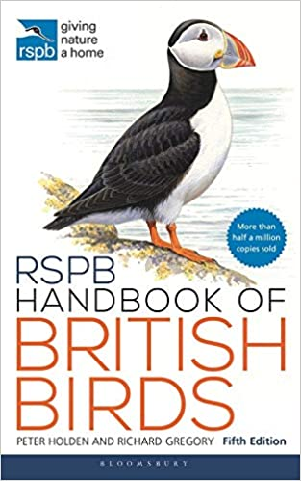

5th ed 2021
ISBN 978-1472980267
Publisher Bloomsbury Wildlife.
Kindle edition also available

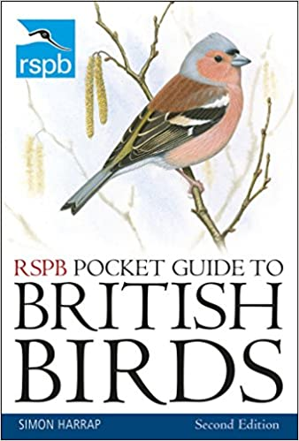

2nd ed 2018
ISBN 978-1472962621
Kindle edition also available

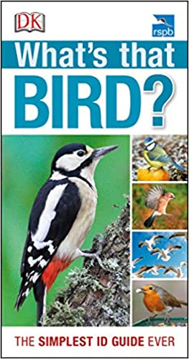

Publisher DK
2012
ISBN 978-1405393508
Author: Rob Hume

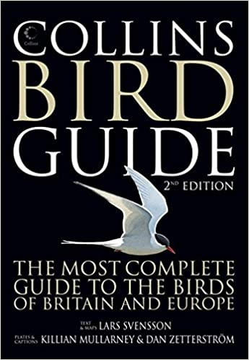

2nd ed 2010 ISBN 9780007268146

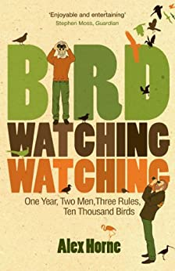

2009
ISBN 9780753515761
Kindle is also available
The story of how the comedian got involved with birdwatching as a means of getting closer to his father.

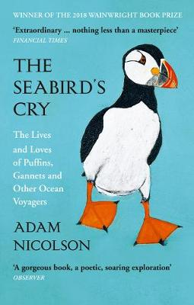

2018 Harper Clolins
ISBN 9780008165703
Kindle available
A really interesting read. Includes some folklore as well as facts about the birds. It seems also to have been republished by an American publisher in 2019 with a different cover and slightly different subtitle.

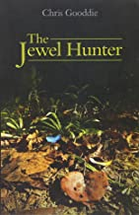
2010 ISBN978-1903657164
Chris Goodie, the author, is a friend of a local RSPB member, who joined him for part of this trip. It’s the account of an expedition to see every species of pitta . These mainly live in tropical places. It’s well written.

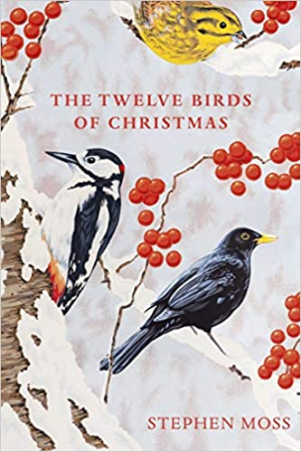

Stephen Moss is an author with many good nature-themed books
2019 ISBN 978-1529110104
Kindle edition also available

